Product Backlog



# **1. Product Backlog**

## **1.1. User Story Map**

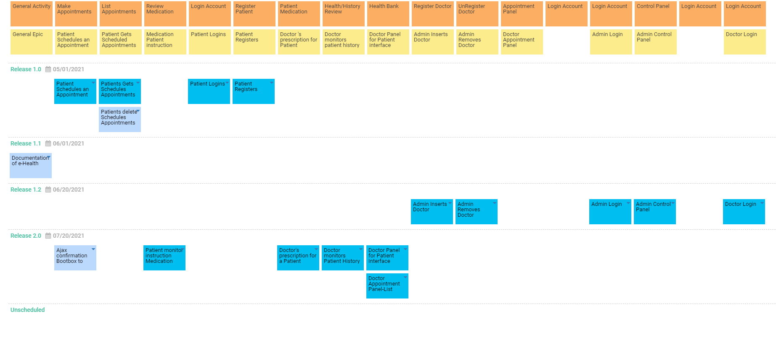

## **1.2. Prioritized User Stories**

| **ID** | **Name** | **Description** | **Epic** | **Status** | **Acceptance Criteria** | **Story Points** | **Priority** | **Risk** | **Split From** | **Due Date** |
| --- | --- | --- | --- | --- | --- | --- | --- | --- | --- | --- |
| US001 | Patient Schedules an Appointment | As a Patient, I want to be able to schedule online appointments | Patient Schedules an Appointment | Approved | Search doctor and pick available appointments, Confirmation | 3 | Must | Low |  |  |
| US002 | Patients Gets Schedules Appointments | As a Patient, I want to be able to see my schedule list so to remove or not to forget when an appointment is. | Patient Gets Scheduled Appointments | Approved | remove appointments, review appointments, Confirmation | 1 | Must | Low |  |  |
| US003 | Patient monitor instruction Medication from Doctor | As a Patient, I want to see my medication instruction so to know the dosages and timing | Medication Patient instruction from Doctor | Approved | See medication instructions, See who is from, See how long to take them and dosages | 1 | Must | Medium |  |  |
| US004 | Patient Logins | As a Patient, I want to sign in to my health services | Patient Logins | Approved | Security check, Patients Logins to main e-health Portal, Another Portal | 2 | Must | Low |  |  |
| US005 | Patient Registers | As a Patient, I want to be able to Register to Health Services | Patient Registers | Approved | security checks | 5 | Must | Low |  |  |
| US006 | Doctor's prescription for a Patient | As a Doctor, I want to write proper steps for a medication so a patient can follow | Doctor 's prescription for Patient | Approved | For each Patient from the Appointment | 3 | Must | Medium |  |  |
| US007 | Doctor monitors Patient History | As a Doctor, I want to review the history of my Patient so to have a clearer understanding | Doctor monitors patient history | Approved | Review previous medications, See Dates information | 3 | Must | Medium |  |  |
| US008 | Doctor Panel for Patient Interface | As a Doctor, I want an easy way to interface with my Patients so to keep organized | Doctor Panel for Patient interface | Approved | List area of all patient interactions, Add Appointments, Edit Appointment Dates if not scheduled from patient, Writes prescription to Patient | 3 | Must | Medium |  |  |
| US009 | Admin Inserts Doctor | As an Admin, I want to register Doctor to the System | Admin Inserts Doctor | Approved |  | 2 | Must | Low |  |  |
| US010 | Admin Removes Doctor | As an Admin, I want to un-register Doctor to the System | Admin Removes Doctor | Approved |  | 2 | Should | Low |  |  |
| US011 | Doctor Appointment Panel-List | As a Doctor, I want to set or unset Appointments | Doctor Panel for Patient interface | Approved | Depends on Doctor Health Bank Panel | 3 | Must | Medium |  |  |
| US012 | Admin Login | As an Admin, I want to login to Health Service Administration Panel | Admin Login | Approved | Another Portal, 1 admin | 2 | Must | Medium |  |  |
| US013 | Admin Control Panel | As an Admin, I want a main area to centralized adjust everything | Admin Control Panel | Approved | Main Panel for Admin interaction to users | 3 | Must | Medium |  |  |
| US014 | Doctor Login | As a Doctor, I want to Sign-In to Health Services. | Doctor Login | Approved | After Admin insert, Another Portal | 2 | Must | Medium |  |  |
| US015 | Ajax confirmation Bootbox to Controller HTTPreq |  | Patient Schedules an Appointment | New |  |  |  |  |  |  |
| US017 | Documentation of e-Health |  | General Epic | New |  |  |  |  |  |  |
| US016 | Patients delete Schedules Appointments |  | Patient Gets Scheduled Appointments | New |  |  |  |  |  |  |